Appendix 7 - Technical Specifications
Supply & Installation of Solar Panel Kits
Reference #: CWW/KHT/0388/2021/03 SOLAR
Specification Details kit for a 3.5KW solar panel for the six targeted health facilities under BRICK Project funded by the European Union

No | Specification details | Unit Size | Number of Health facilities | Total number of Items each Health Facility | Total items to be procured
1 | Solar panel 250/270 Watt solar panel 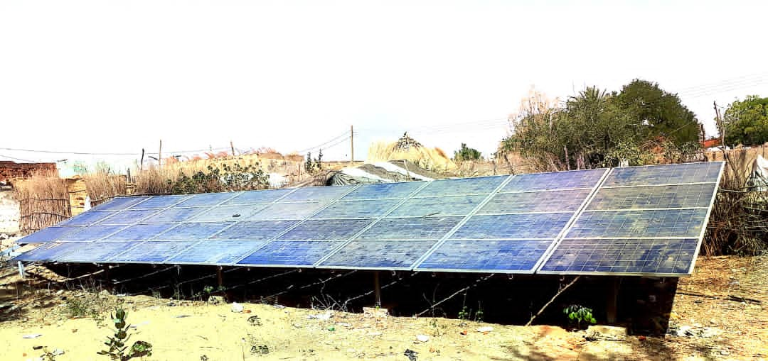 | pcs | 6 | 10 | 60
2 | Combiner Box 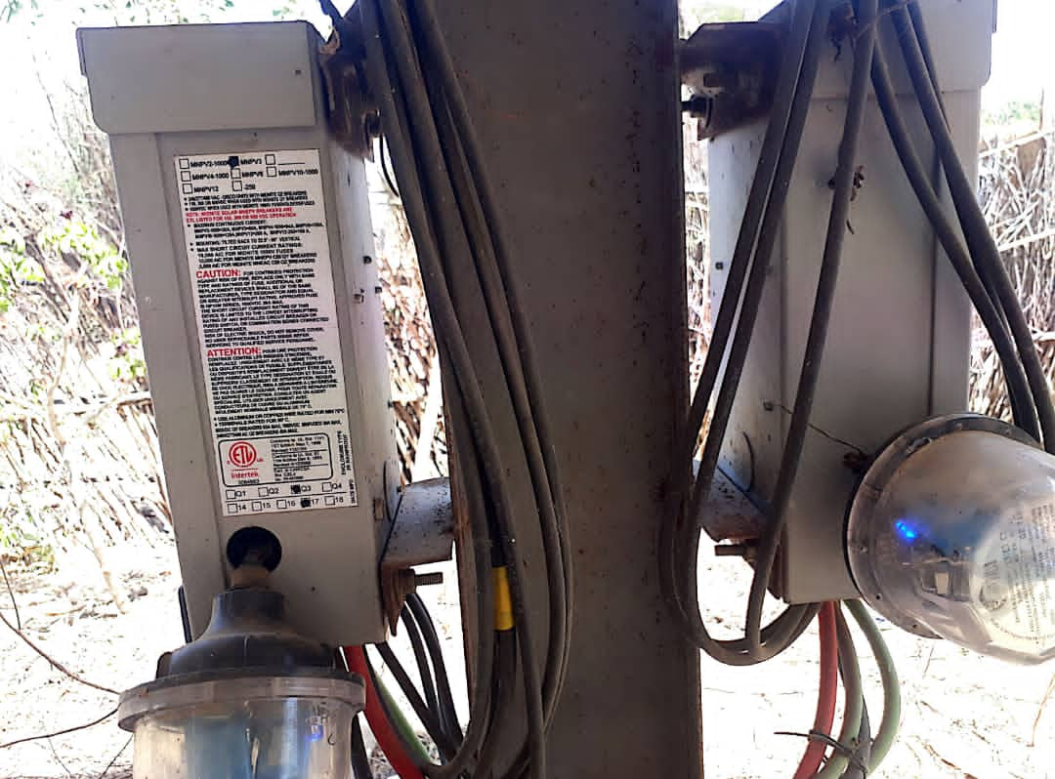 | pcs | 6 | 1 | 6
3 | Charge controller 48V 50A (added a picture)  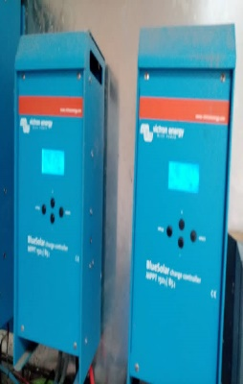  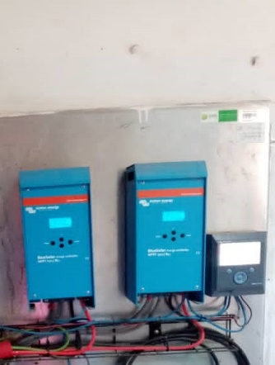 | pcs | 6 | 2 | 12
4 | 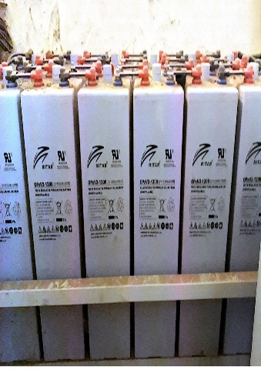  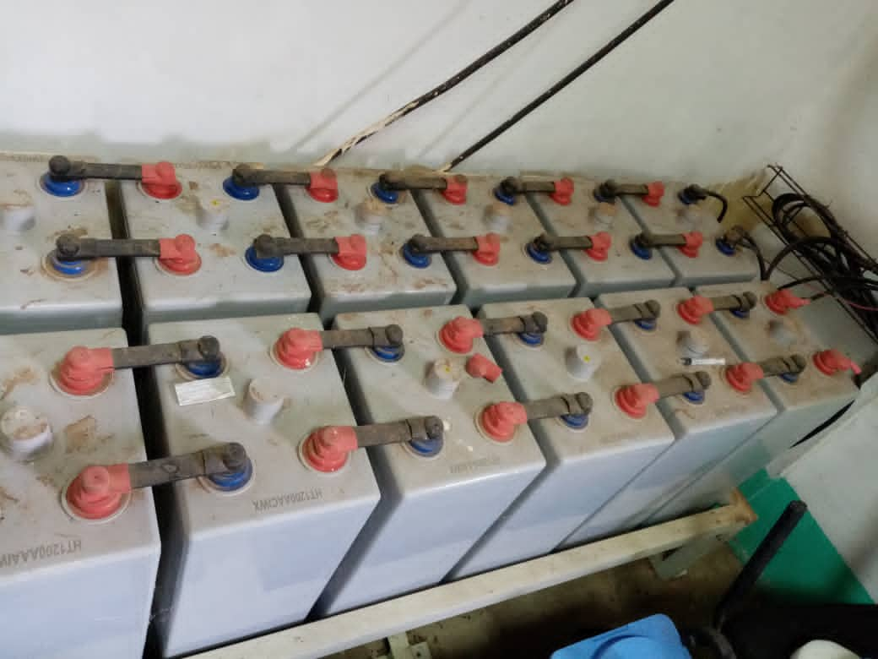  Battery 12V 100AH (Added a picture) | pcs | 6 | 8 | 48
5 | Off-grid inverter 3500W 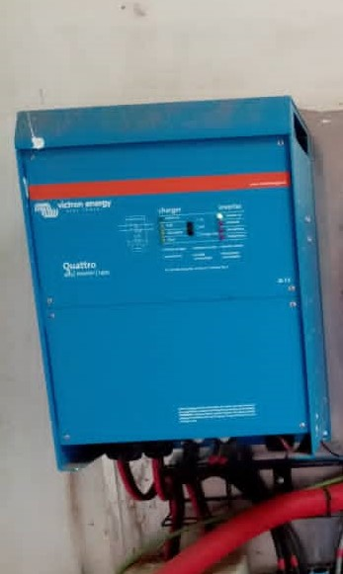 | pcs | 6 | 2 | 12
6 | 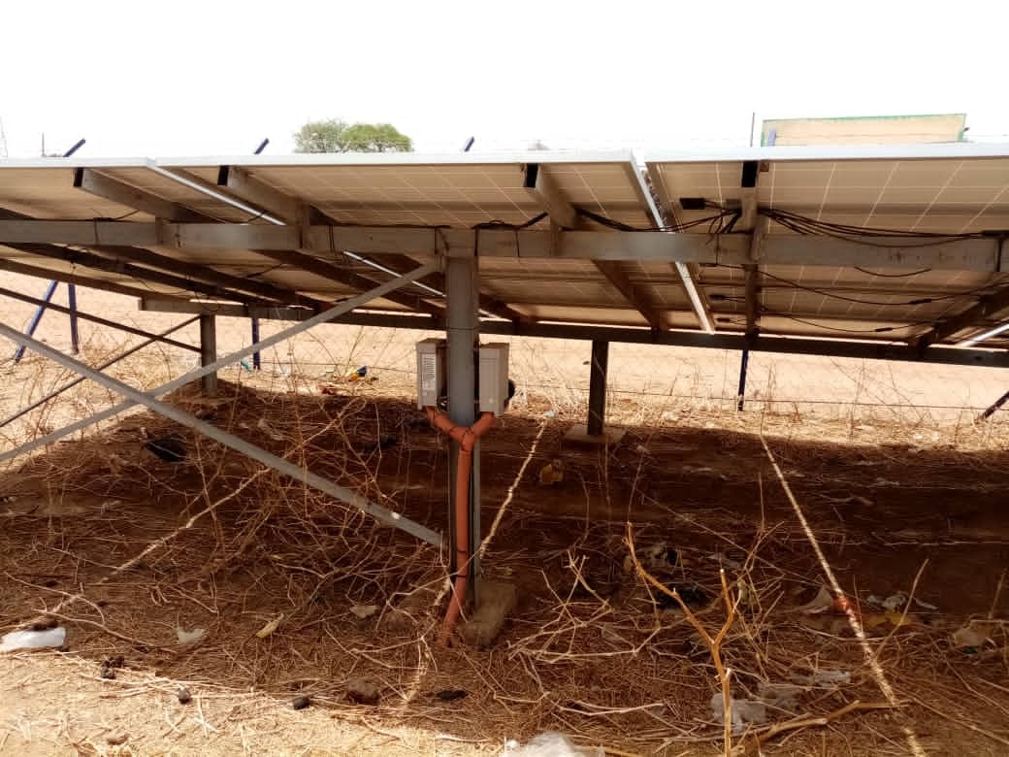  Mounting support, ground It`s ground mounting with metal support on the ground. | set | 6 | 1 | 6
7 | Cable single-core 4mm2 and 10 mm2 PV cable | meters | 6 | 30 | 180

Installation
The chosen supplier will travel to the listed health facilities below and all costs for this travel to install must be include in the final bid. The submitted bid value will be the final offer with ALL costs included for the supply and Installation of these panels.

The installation is a ground installation as shown in the ground-mounting photograph.

The Health Facilities are located as follows

Locality | No of Health Facilities | Name of Health Facilities
Muglad | 4 | Muglad,  Nematine,  Mugadama  Siteb
Meiram | 1 | Meiram
Keilak | 1 | Keilak

There must be a warranty of 6 months for the materials and workmanship during installation.

